SIMATS ENGINEERING (SAVEETHA SCHOOL OF ENGINEERING)
Department of Computer Science and Engineering

ASSESSMENT TOOL 1 – Coding Challenge Task

Course Code: | CSA06 | Course Title: | Design and Analysis of Algorithms
CO Assessed: | CO4: Articulation (BL4, BL5) | Assessment: | Assessment Tool 1 – Coding Challenge Task
Weightage: | 40% of CIA | Total Marks: | 100
CO4 Statement: | Solve optimization problems using dynamic programming and greedy strategies.
Student Name: | N.Thanveer basha | Reg. No.: | 192372122
Section / Batch: | CSE(AI) | Date: | 20.08.2026

Instructions to Students
- Answer the following question. Total Marks: 100.
- Carefully analyze the given questions.
- Write clear code for the given problem.
- Analyze the Time complexity and Space complexity of your code using dynamic programming and greedy strategies

Question Type | Focus Area | Questions
Coding Challenge Task | Focus on Code and analyze optimization problems using dynamic programming and greedy strategies | Q1

SECTION A – Coding Challenge Task

Code of Conduct
I _____N.Thanveer(192372122)_ (Name / Reg No) certify that this submission is my original work and that I have adhered to the guidelines specified for this assessment. I understand that any violation of academic integrity rules will result in disciplinary action.
Signature of the Student: ___N.Thanveer______________________

RUBRICS FOR CALCULATION

Coding Challenge Task

Criteria | Weightage | Level 4 (Exemplary) | Level 3 (Proficient) | Level 2 (Developing) | Level 1 (Beginning)
Problem Understanding | 20% | Clearly understands problem constraints, edge cases, and competitive requirements | Understands  problem with  minor gaps in constraints | Partial understanding; misses key constraints | Misinterprets problem or constraints
Algorithm | 25% | Selects optimal algorithm with best time and space complexity for  competitive constraints | Uses efficient algorithm with  minor scope for improvement | Uses basic/inefficient approach | No clear algorithmic approach
Code Implementation | 20% | Writes correct, efficient, and clean  code that passes all constraints | Code works with minor errors or inefficiencies | Partially correct code; fails for some  cases | Code does not execute or gives incorrect results
Competitive Performance | 20% | Solves problem within time limits and  handles large inputs effectively | Solves within acceptable time with minor delays | Struggles with time limits or larger inputs | Unable to solve within time constraints
Test Case Handling | 15% | Handles all test cases including edge and hidden cases | Handles most test cases | Misses important edge cases | Fails on multiple test cases

Marks Evaluation:
Criteria | Wt. | Level 4 –  Exemplary | Level 3 –  Proficient | Level 2 –  Developing | Level 1 –  Beginning
Problem Understanding | 20%
Algorithm | 25%
Code Implementation | 20%
Competitive Performance | 20%
Test Case Handling | 15%
Total Marks (100):

Faculty In-charge | Course Coordinator | Head of Department
Name: | Name: | Name:
Signature: _______________ | Signature: _______________ | Signature: _______________
Date: ___________________ | Date: ___________________ | Date: ___________________

QUESTION AND SOLUTION :-

MAXIMUM SALARY SUBARRAY
Given an array of integers containing both positive and negative values, find the contiguous subarray that has the largest possible sum. The chosen elements must appear consecutively in the original array. The objective is to determine the maximum sum that can be obtained from any such subarray. Use Dynamic Programming to compute the optimal result efficiently. Input Format: n = number of elements arr[] = array elements Sample Input: n = 5 arr = -2 3 4 -1 -2 Expected Output: Maximum Sum = 4

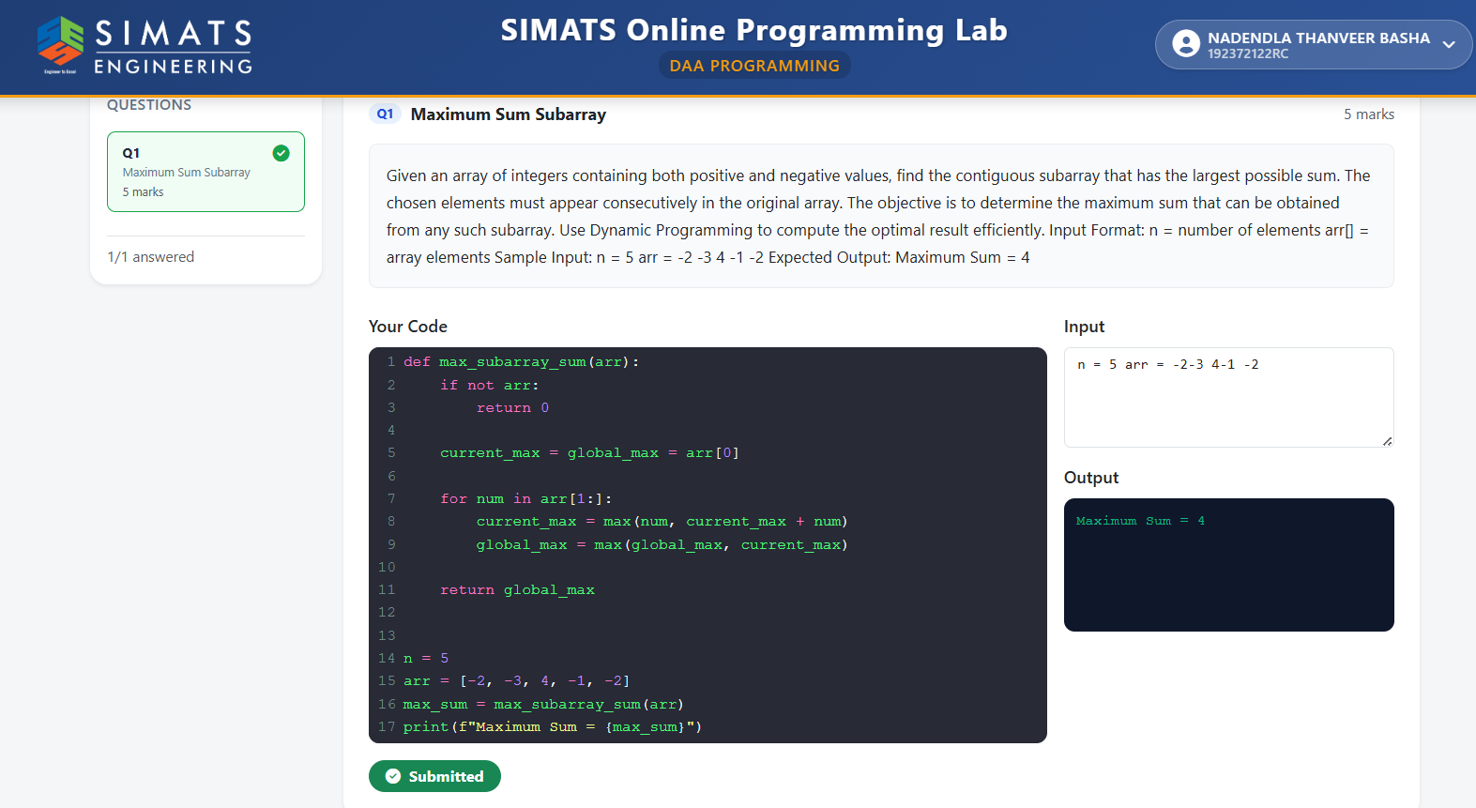

The Maximum Salary Subarray problem is an important optimization problem that can be solved efficiently using Dynamic Programming. The problem is based on finding a contiguous portion of an array that produces the maximum possible sum. The array may contain both positive and negative integers. A positive value can be considered as a salary or profit gained from a particular period, while a negative value can represent a loss, expense, or deduction. The objective is to select a continuous sequence of values that gives the highest total salary or profit.

The important condition is that the selected elements must be consecutive in the original array. Elements cannot be selected randomly from different positions. This makes the problem different from problems such as the maximum subsequence problem.

For example, consider the array:
[-2, 3, 4, -1, -2]

Different contiguous subarrays can be formed from this array. The subarray [3, 4] produces a sum of 7, which is greater than the sum of any other contiguous subarray. Hence, the maximum salary or maximum subarray sum is 7.
The problem can be solved using a Dynamic Programming technique commonly known as Kadane's Algorithm. It reduces the computational complexity from quadratic time to linear time.

